Emmanuel Twum

Foundations of Programming Python

Randal Root

Assignment 01

9/27/2017

How to Execute a Python Script Using a Batch File

The purpose of this paper is to describe how to use a batch file to execute python and run a python script. This paper assumes that the reader has installed python and is running a windows operating system. This paper also assumes that the reader has some basic understanding of computer functions such as right clicking and double clicking.

The first step in using a batch file to run a python script is the creation of the python script file. You will need to open IDLE from the start menu. Once IDLE is open create a script by going to file then new file (see figure 1). Once the new file is open type in the following code: input("It is working if it pauses for input!"). Now save the script file as test.py in a folder called _PythonClass on the C drive.

Figure 1: Creating a new script file in IDLE

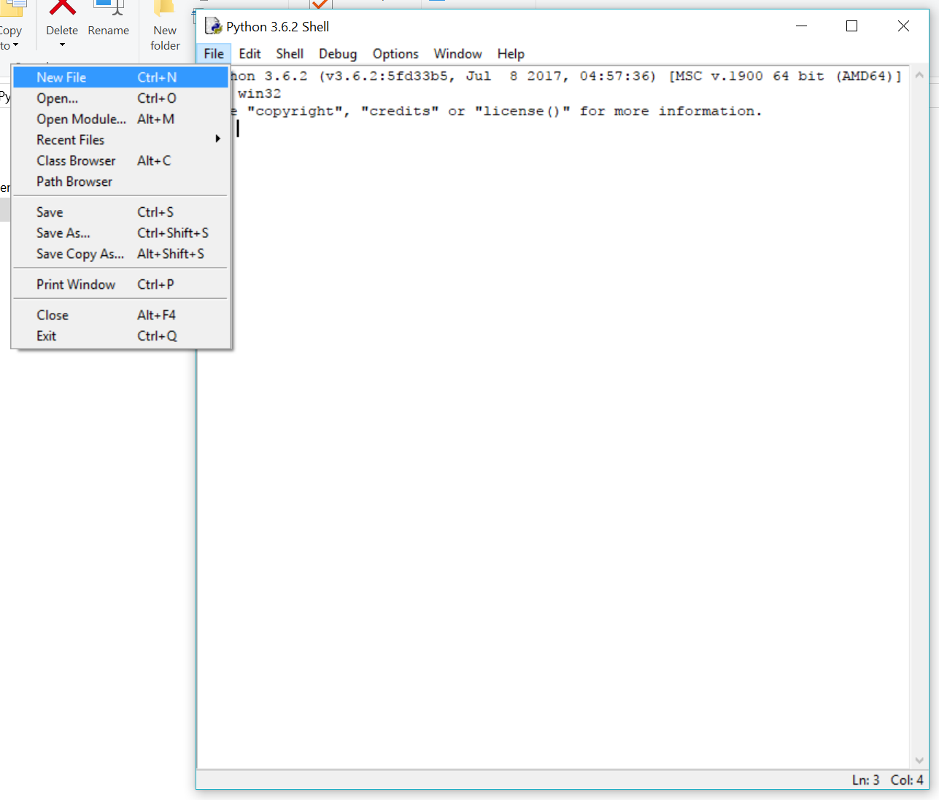

The second step in this process is the creation of the batch file. In order to create the batch file you will need to right click anywhere on your desktop or a designated folder and create a text document (see figure 2).

Figure 2: creating a text document

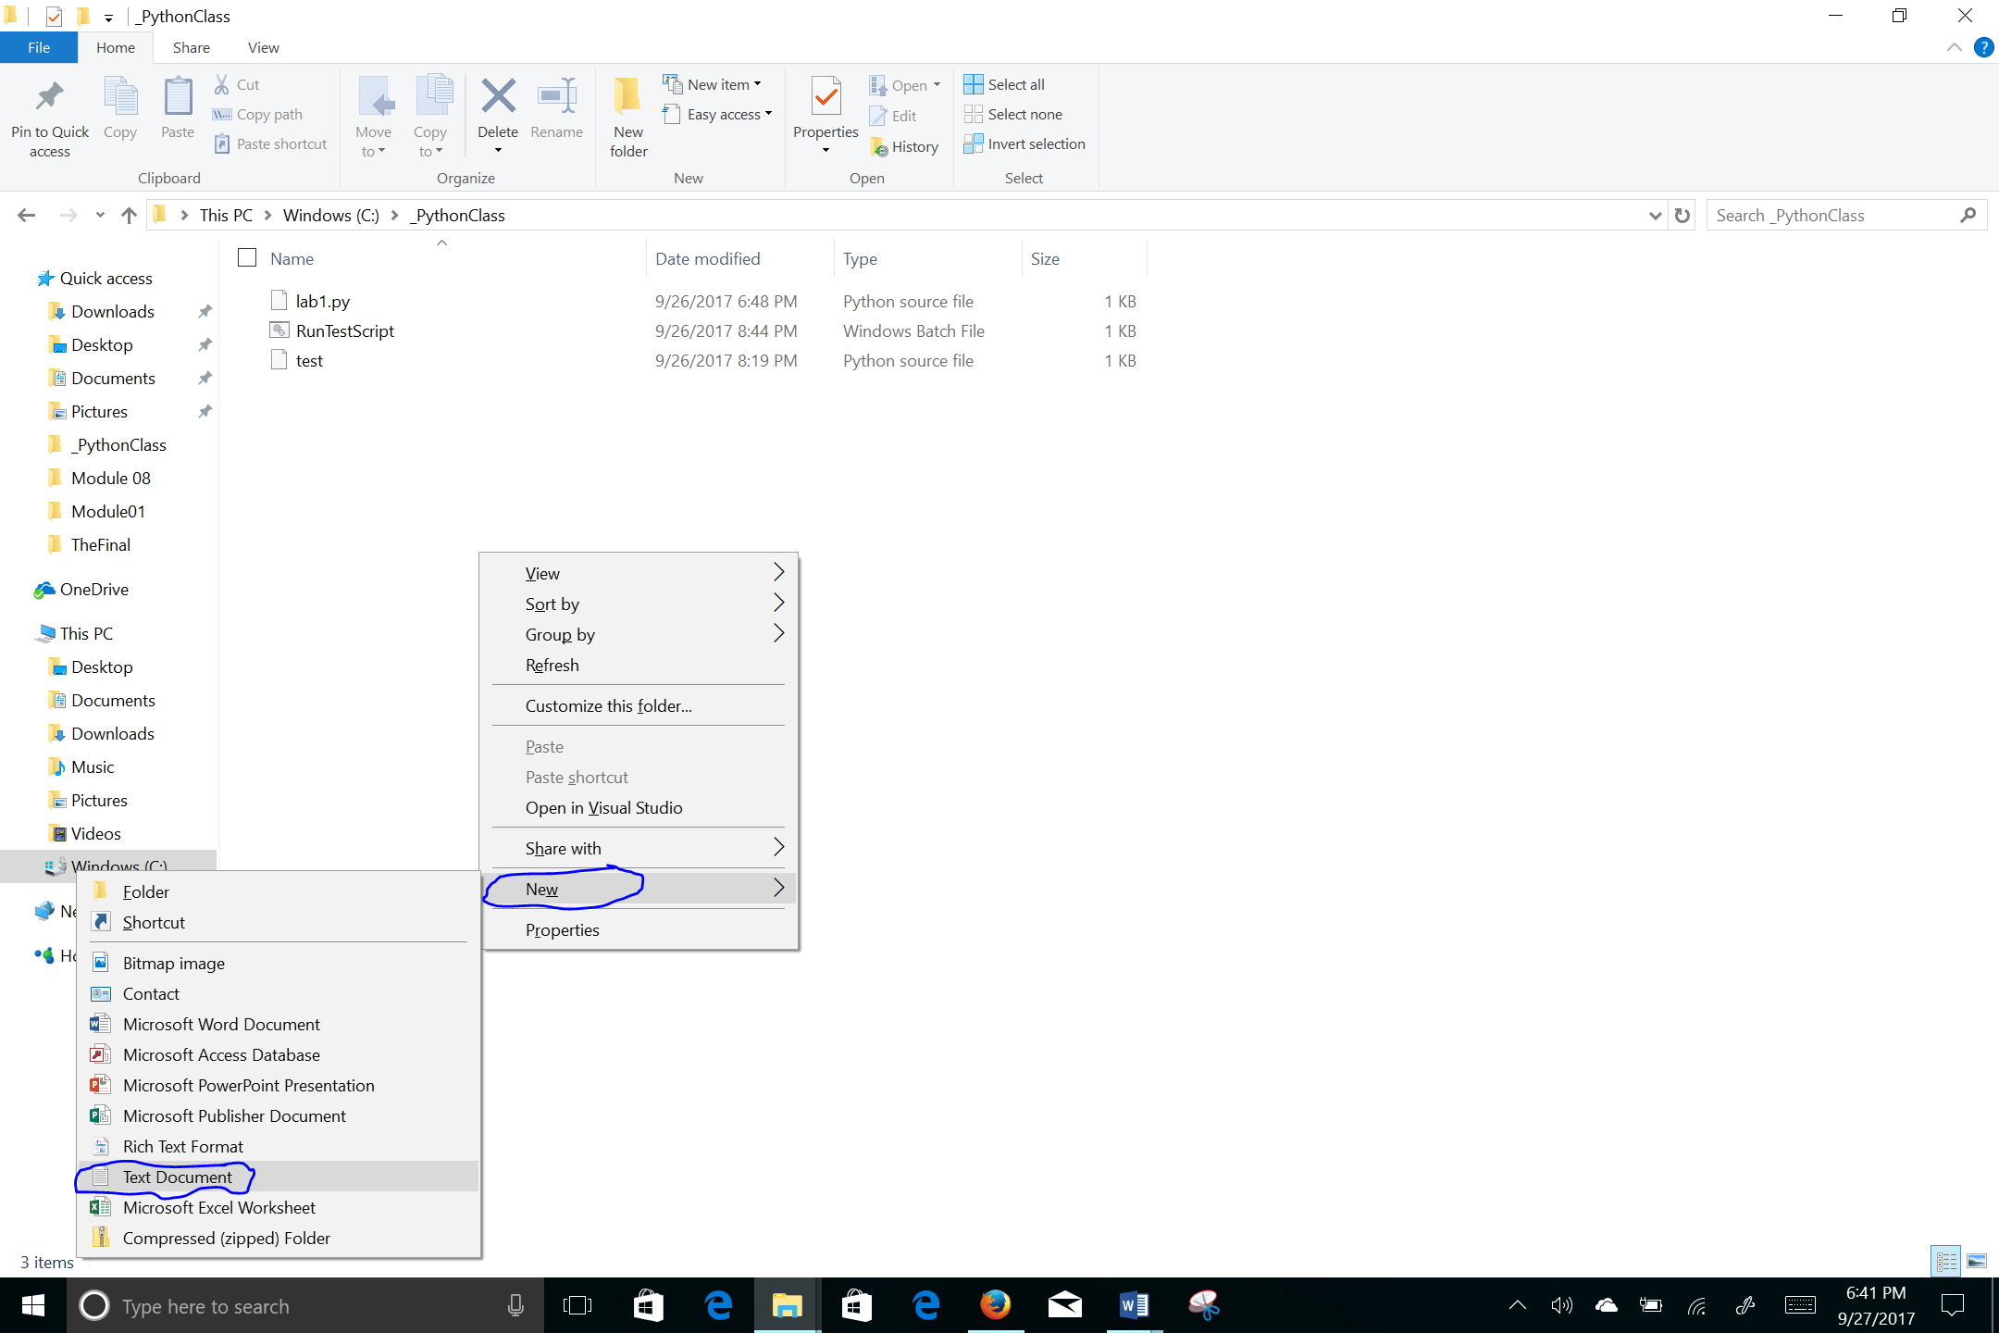

Once the text document is created double click and open the file. Once open you will enter the following text: cd C:\Program Files\Python36 start python.exe c:\_PythonClass\test.py pause (see figure 3). As needed, you will need to change C:\Program Files\Python36 to the directory of your python.exe file. The directory is simply the location of where the python.exe file is located on your computer. You can do a simple search if you’re unsure where it’s located. Also, if the test.py script wasn’t saved in c:\_PythonClass directory you will need to change the text to match where the script file is located

Figure 3: Entering data into the text document

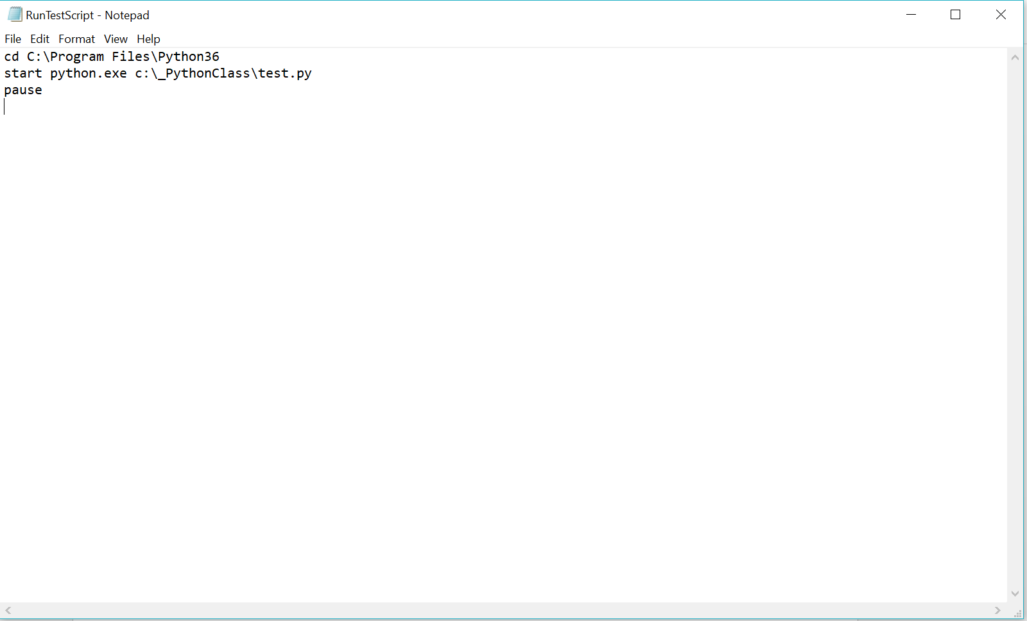

Once the information in the text file is ready to go you will now save it as a .bat file. To do this you will hit file save as then change the ‘Save As Type’ to ‘All Files’ by hitting the drop down (See figure 4). For the file name save it as RunTestScript with an extension of .bat so it saves as a batch file (See figure 4).

Figure 4: Saving the text document as a batch file

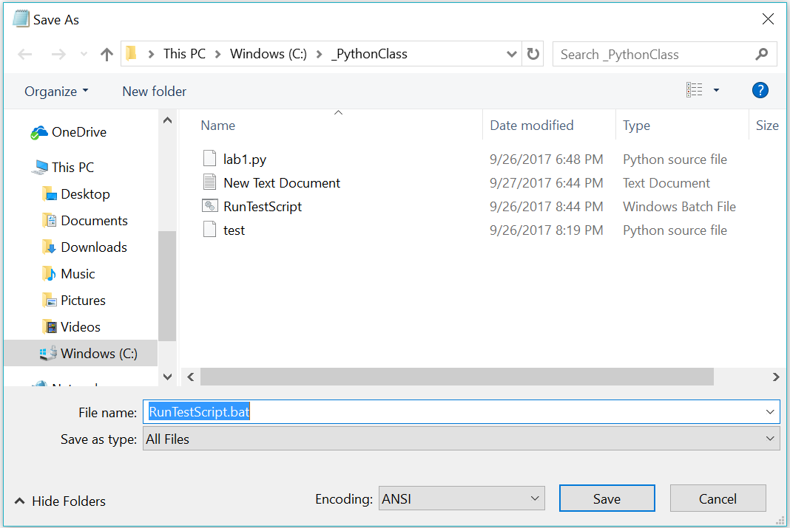

The last step in the process is to test the batch file to make sure it runs correctly. Navigate to the location of the batch file on your computer and double click it. The windows command should now open to run python.exe and the test.py script (See figure 5).

Figure 5: Running the batch file and script

